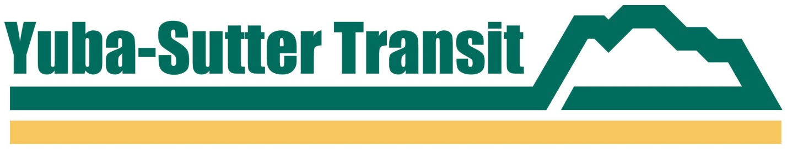

**PRESS RELEASE**

**YUBA-SUTTER TRANSIT**

**2100 B STREET, MARYSVILLE, CA 95901**

**Contact: Jessica Solis or Matthew Mauk**

**Phone: (530) 634-6880**

**FAX: (530) 634-6888**

**FOR IMMEDIATE RELEASE**

**NO SACRAMENTO SERVICE ON MARCH 31st FOR CESAR CHAVEZ HOLIDAY**

*March 24, 2025, Marysville, CA* – Yuba-Sutter Transit will not operate any Sacramento   
Commuter services on Monday, March 31, 2025, due to the State’s observance of the Cesar Chavez holiday. All other local, rural, and Dial-A-Ride services will operate as scheduled on that day.

Sacramento Commuter services will resume on Tuesday, April 1, 2025, with the addition of new service options to the May Lee State Office Complex (MLSOC) on Richards Blvd. and 7th Street in the River District of Sacramento.

For more information, please visit our website at [www.yubasuttertransit.com](http://www.yubasuttertransit.com).

###