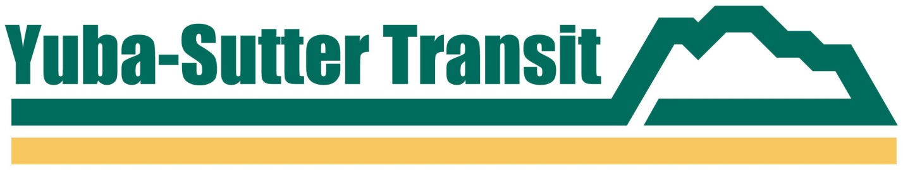

**PRESS RELEASE**

**YUBA-SUTTER TRANSIT**

**2100 B STREET, MARYSVILLE, CA 95901**

**Contact: Jessica Solis or Matthew Mauk**

**Phone: (530) 634-6880**

**FAX: (530) 634-6888**

**FOR IMMEDIATE RELEASE**

**BUS SERVICE TO BE DETOURED FOR HOLIDAY EVENTS IN YUBA CITY AND OLIVEHURST**

*December 10, 2024, Marysville, CA* –Yuba-Sutter Transit’s Routes 1 and 2 will not serve Plumas Street on Saturday, December 14th due to street closures for the annual Christmas Stroll event held in downtown Yuba City.

Due to the early closure of Plumas Street from Colusa Avenue to Bridge Street for the event, Yuba-Sutter Transit’s local fixed route service will be re-routed off Plumas Street all day on December 14th. Instead, Route 1 will operate on Olive Street between Colusa Avenue and Forbes Avenue, and Route 2 will operate on Shasta Street between Colusa Avenue and Bridge Street. The Plumas Street bus stops at Church Street and Bridge Street will not be served during this time, nor will the Route 1 stops at Forbes Avenue and Almond Street.

Yuba-Sutter Transit’s services will also be detoured from Olivehurst Avenue on Saturday, December 14th for the 55th edition of the Olivehurst Christmas Parade. Due to event street closures, which are scheduled to begin at 3:00 p.m., Yuba-Sutter Transit’s Route 3 service will be detoured in both directions from Olivehurst Avenue to Western Avenue between 10th and 3rd Avenues through the end of the scheduled service.

For more information, please visit our website at <yubasuttertransit.com.>

###